RTOS Task Scheduling

PROGRAM
#include <stdio.h>

typedef struct {
char name[20];
int priority;
int execution_time;
} Task;

int main() {
Task tasks[] = {
{"Task1", 3, 5},
{"Task2", 1, 3},
{"Task3", 2, 4}
};

int n = 3;

printf("RTOS Task Scheduling in C\n");
printf("Execution Order:\n");

// Higher priority executes first
for (int p = 3; p >= 1; p--) {
for (int i = 0; i < n; i++) {
if (tasks[i].priority == p) {
printf("%s -> Priority: %d, Time: %d ms\n",
tasks[i].name,
tasks[i].priority,
tasks[i].execution_time);
}
}
}

return 0;
}
OUTPUT

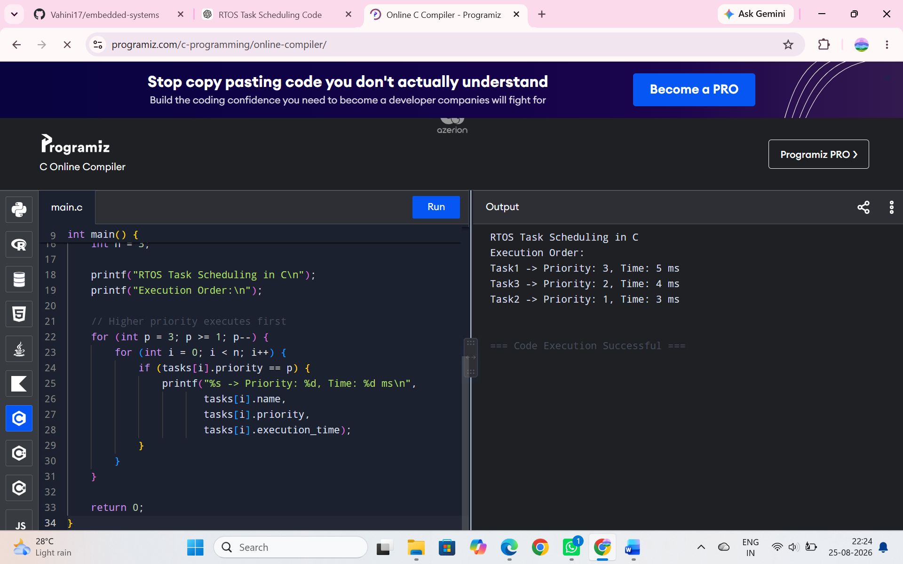

PROGRAM
#include <iostream>
#include <vector>
#include <algorithm>
using namespace std;

struct Task {
string name;
int priority;
int execution_time;
};

int main() {
vector<Task> tasks = {
{"Task1", 3, 5},
{"Task2", 1, 3},
{"Task3", 2, 4}
};

sort(tasks.begin(), tasks.end(),
[](Task a, Task b) {
return a.priority > b.priority;
});

cout << "RTOS Task Scheduling in C++\n";
cout << "Execution Order:\n";

for (auto t : tasks) {
cout << t.name
<< " -> Priority: " << t.priority
<< ", Time: " << t.execution_time << " ms\n";
}

return 0;
}
OUTPUT
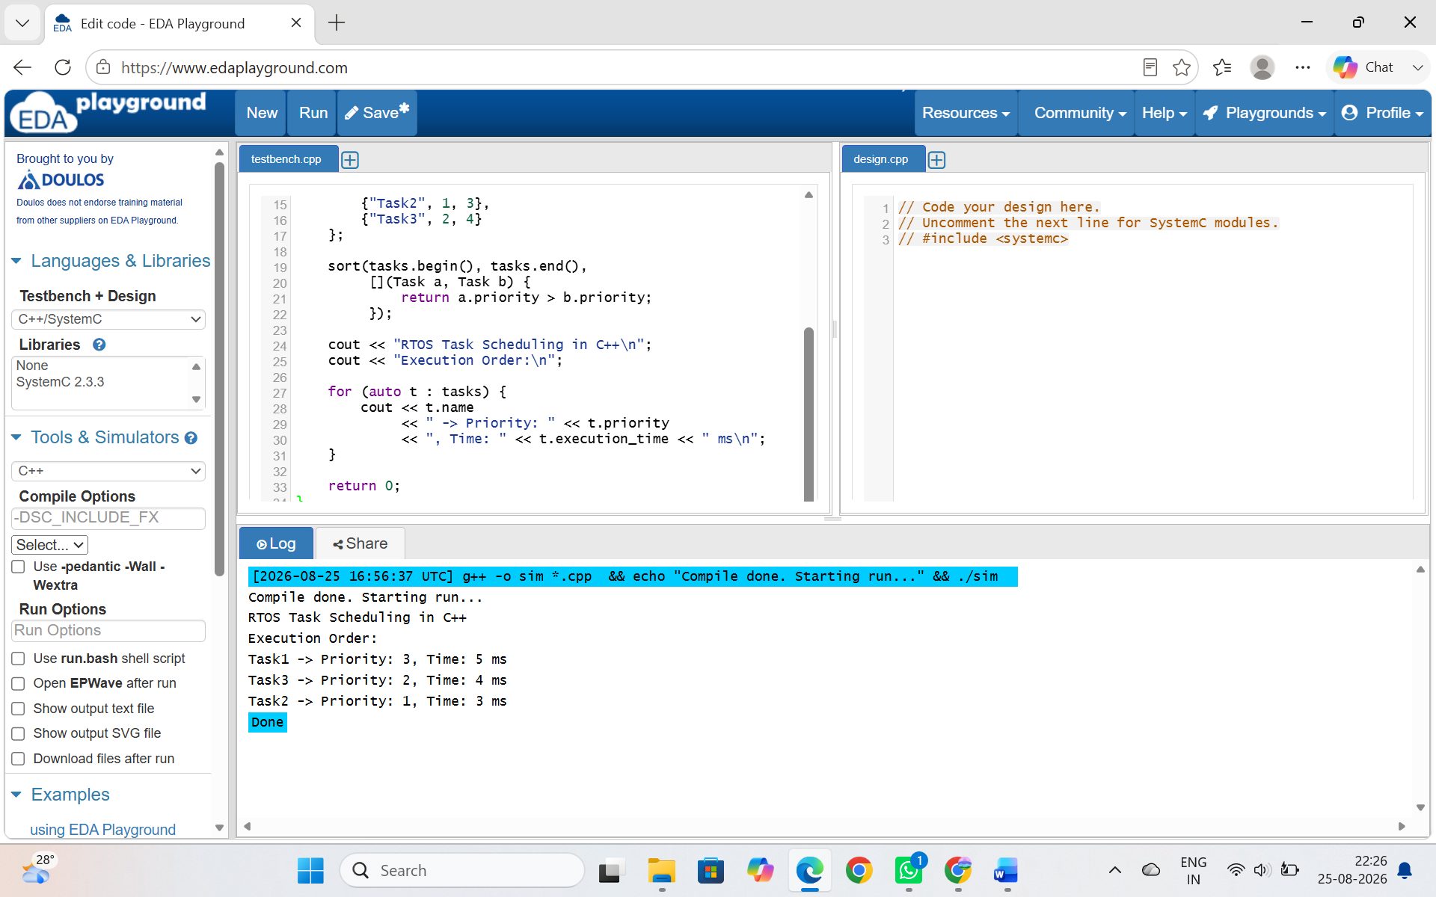

RESULT
C provides a simple and lightweight implementation suitable for resource-constrained RTOS systems, while C++ provides easier task management through structures, vectors, sorting, and higher-level programming features.

